**ABSTRACT**

Waste management is one of the primary problem that the world faces irrespective of the case of developed or developing country. The key issue in the waste management is that the garbage bin at public places gets overflowed well in advance before the commencement of the next cleaning process. It in turn leads to various hazards such as bad odour & ugliness to that place which may be the root cause for spread of various diseases. To avoid all such hazardous scenario and maintain public cleanliness and health a smart garbage monitoring system using IoT is used. The main theme of the work is to develop a smart intelligent garbage alert system for a proper garbage management. This project proposes a smart alert system for garbage clearance by giving an alert signal to the municipal web server for instant cleaning of dustbin with proper verification based on level of garbage filling. This process is aided by the ultrasonic sensor which is interfaced with Node-MCU to check the level of garbage filled in the dustbin and sends the alert to the municipal web server once if garbage is filled. The whole process is upheld by an embedded module integrated with IoT Facilitation. A web application is developed and linked to a web server to intimate the alerts from the microcontroller to the urban office and to perform the remote monitoring of the cleaning process, done by the workers, thereby reducing the manual process of monitoring and verification.

**TABLE OF CONTENTS**

List of Figures i

List of Tables ii

Nomenclature iii

**Chapter 1: Introduction**

1.1 Overview 1

1.2 Aims and objectives 1

1.3 Justification 2

1.4 Scope of the project 3

**Chapter 2: Literature Review & Problem Identification**

2.1 Literature Review 4

2.2 Problem Identification 5

**Chapter 3: Methodology** 6

**Chapter 4:**  **Materials used**

4.1 Node-MCU 8

4.2 Breadboard 11

4.3 Ultra Sonic Sensor 13

4.4 IC 7805 Regulator 16

4.5 Jumper wires 18

4.6 Slide switch 19

4.7 9V Battery 20

4.8 LED 21

**Chapter 5:**  **Construction and Design**

5.1 Design of the Smart Garbage Monitoring System 24

5.2 Steps in construction of Project 26

5.3 Circuit diagram of Smart Garbage Monitoring System 26

**Chapter 6:**  **Results** 29

**Chapter 7: Conclusion and Future scope** 30

**References** 31

**Appendices** 32

**Biodata** 39

**LIST OF FIGURES**

|  |  |  |
| --- | --- | --- |
| **Fig. No** | **Name of the Figures** | **Page. No** |
| 1 | Node-MCU | 8 |
| 2 | Node-MCU pin diagram | 11 |
| 3 | Bread board | 12 |
| 4 | Ultra Sonic Sensor | 14 |
| 5 | IC 7805 Regulator | 16 |
| 6 | IC7805 pin diagram | 17 |
| 7 | Female to Male jumpers | 18 |
| 8 | Female to Female jumpers | 18 |
| 9 | Male to Male jumpers | 19 |
| 10 | Slide switch | 19 |
| 11 | 9V Battery | 20 |
| 12 | Connecter | 21 |
| 13 | LED | 21 |
| 14 | LED pin diagram | 22 |
| 15 | Schematic sketch of garbage monitoring system using IoT | 24 |
| 16 | Hardware of garbage monitoring system using IoT for a single dustbin | 25 |
| 17 | Complete model of IoT based garbage monitoring system | 25 |
| 18 | Connecting with Firebase | 27 |
| 19 | Output on a webpage when bins are empty | 28 |
| 20 | Output on a webpage when bins are full | 28 |

**LIST OF TABLES**

|  |  |  |
| --- | --- | --- |
| **S.No** | **Name of the table** | **Page. No** |
| 1 | Node-MCU devkit | 10 |

**NOMENCLATURE**

|  |  |  |
| --- | --- | --- |
| **S.No** | Acronym | Abbreviations |
| 1 | IoT | Internet of Things |
| 2 | SDK | Software Development Kit |
| 3 | LED | Light Emitting Diode |

**CHAPTER 1**

**INTRODUCTION**

**1.1 OVERVIEW**

In the present scenario as the population is increasing day by day, the environment should be clean and hygienic. In most of the cities, the overflowed garbage bins creating an unhygienic environment. This will further lead to the arise of different types of unnamed diseases. This will degrade the standard of living. To avoid all such situations this project gives a clear picture of IoT based garbage monitoring system to keep environment clean and safe. This project Garbage monitoring system using IoT is a very innovative system which will help to keep the cities clean. This system monitors the garbage bins and informs about the level of garbage collected in the garbage bins via a web page. For this, the system uses ultra sonic sensor placed over the bins to detect the garbage level and compare it with the level of the garbage bins depth. A web page is built to show the status to the user monitoring it. The web page gives a graphical view of the garbage bins. The display shows the condition of the trash stage. Thus this scheme helps to maintain the city sparkling by informing about the trash levels of the bins by providing graphical representation of the bins via a web page.

**1.2 AIM AND OBJECTIVES**

The main objective of this project involves applying IoT technology (electronics and applications) to the current urban waste management scenario and enables a two way communication between the infrastructures deployed in the city and the operators/administrators. A centralized system for real-time monitoring is the goal to achieve. In this way both the municipal and citizens benefit from an optimized system which results in major cost savings and less urban pollution.

In the existing system garbage is collected by corporation by weekly once or by 2 days once. Though the garbage shrinks and overflows the garbage bin and spread over the roads and pollutes the environment. The smell will be heavy and produces air pollution and spreads disease. The street dogs and animals eat the waste food and spreads over the area and creates dirty environment to avoid such situation we are planning to design IoT Based Garbage Management For Smart Cities.

In this proposed system there are multiple dustbins located through the city or the campus, these dustbins are provided with low cost embedded device which helps in tracking the level of the garbage bins and an unique ID will be provided for every dustbin in the city so that it is easy to identify which garbage bin is fill. When the level reaches the threshold limit, the device will transmit the level along with the unique ID provided. These details can be accessed by the concern authorities from their place with the help of internet and an immediate action can be made to clean the dustbins.

The main objective of this project involves applying IoT technology (electronics and applications) to the current urban waste management scenario and enables a two way communication between the infrastructures deployed in the city and the operators/administrators. A centralized system for real-time monitoring is the goal to achieve. In this way both the municipal and citizens benefit from an optimized system which results in major cost savings and less urban pollution.

 To make use of the best available data in order to identify the location and potential impacts that natural hazards as floods can have on people, property and natural environment

 To improve the systems of warning and emergency communications

 To provide support for the public authorities and government institutions’ hazard mitigation efforts, including planning and action coordination

 To inform the public on the risk exposure to natural hazards and how they can get prepared, respond, recover and mitigate the impacts of such events

So given the above mentioned objectives, the project will offer an opportunity for collective problem solving, knowledge sharing, social exchange and community-wide participation at local and global scale. This will lead to an insight into the information and preparedness requirements of local communities and the development of solutions adapted to the social realities.

Secondly, it will lead to a closer cooperation and coordination for flood forecasting and warning services of public institutions based on user needs.

Thirdly, based on the flood event studies, and including consultations with affected communities and other recipients of flood warnings, improved technical means of detecting the areas at imminent risk and warning more effectively, will be developed.

Technically the project will focus on developing a collaborative platform that will link citizen, public authorities and other stakeholders and on enabling the public to be warned en masse so that actions can be taken to reduce the adverse effects of the flood.

**1.3 JUSTIFICATION**

This waste management system using IoT is very useful for smart cities and even the rural areas as equally. Even in the rural areas lack of the garbage management has been leading to various diseases that have been taking shape in different aspects. In order to eradicate this kind of widespread the root cause has to be eliminated. Hence the monitoring will widely help them take the necessary precautions and build the health in to the rural areas. We have seen that, in cities there are different dustbins located in the different areas and dustbins get over flown many times and the concerned people do not get information about this. This system is designed to solve this issue and will provide complete details of the dustbin located in the different areas throughout the city.

The concerned authority can access the information from anywhere and anytime to get the details. Accordingly they can take the decision on this immediately. In addition to the added advantages of being able to monitor the garbage bin over various areas.

The system once set, has a very small requirement of power and hence the entire system becomes highly cost efficient. The Wi-Fi module integrated into this system aids in continuous flow of updated data into the local authorities’ data bases. The system has various maker-checker processes in place to ensure that the system doesn’t receive too much power or doesn’t malfunction due to any transmission issues.

The unique Wi-Fi channel dedicated to the system aids the monitoring and when it is at normal level. The channel dedicated to this shows a flat line or a 0 in simple terms.

We have tried to make this system very user friendly that even a laymen can make complete use of this system without much technical knowledge. High endurance and low maintenance make this system highly competent.

**1.4 SCOPE OF THE PROJECT:**

By implementing this proposed system the cost reduction, resource optimization, effective usage of smart dustbins can be done. This system indirectly reducing traffic in the city . In major cities the garbage collection vehicle visit the area’s everyday twice or thrice depends on the population of the particular area and sometimes these dustbins may not be full. This System will inform the status of each and every dust bin in real time so that the concerned authority can send the garbage collection vehicle only when the dustbin is full. The scope for the future work is this system can be implemented with time stamp in which real-time clock shown to the concern person at what time dust bin is full and at what time the waste is collected from the smart dustbins. This project can also be used in the ‘SMART CITY ‘.This project is also helpful in the Government project of “SWACHH BHARAT ABHIYAN”.

**CHAPTER 2**

**LITERATURE REVIEW & PROBLEM IDENTIFICATION**

**2.1 LITERATURE REVIEW**

The idea of smart garbage bins and systems have been in discussion for quite a long time. The technologies used at disposal to develop this smart system have also evolved, Internet of Things (IoT). Each idea seems to be similar but is slightly different at its core and this proposed work is no exception from the same. After the IoT field, finding its hold in our lives, this is the original plan for designing a smart garbage collection system which has provision for citizen participation and analysis of data for better decision making. At hardware level, the smart system is a garbage bin with ultrasonic sensor, a micro-controller and Wi-Fi module for transmission of data. The worldwide implementation of Internet of Things is possible with a Cloud centric vision. This work exploits the future possibilities, key technologies and application that are likely to drive IoT research. But a strong foundation to this work is provided, where the basics and applications of Node-MCU board is explained. As we would discuss further, the citizen participation part of this system is quite influenced by their work.

Therefore this literature survey identifies

• Need for solution to manage the amount of waste generated by buildings and other large sectors.

• Detection using load sensors present but no method of real time action to be taken on the same.

• Occupancy detection system present but no flexible security feature present.

**2.2 PROBLEM IDENTIFICATION**

As it stands, we are currently moving towards one of the most difficult phases of the country in terms being able to handle the amount of waste that the country produces each year. India is one of the fastest growing economies and which such big task comes the task of not only being able to develop the country to be economically sound but also to help the citizens grow and aid the nation in becoming a developed nation. All of this comes with the adaptability to technology and to be able to use it to our advantage. Trash, garbage, disposables are a huge threat to the nation. Traditionally where ever trash accumulates the diseases are prone to rise, hence this project here is to take on such issues that we often ignore or take for granted. That begins with managing the garbage produced. Generation of garbage or waste is increasing very highly with the increase of population, industrial development, change in consumption habit and the movement of the population into a more luxury life, where they do not really bother on pondering over the waste management. As the concept of smart cities is very much trending these days and the smart cities cannot be complete without smart waste management system. There needs to be system that gives prior information of the filling of the bin that alerts the municipality so that they can clean the bin on time and safeguard the environment. To avoid all such situations we intend to propose a solution for this problem "Smart Garbage Bin", which will alarm and inform the authorized person when the garbage bin is about to fill. Then message will be send to the authorized person to collect the garbage from the particular area. This system maintains a dry waste and a wet waste separately. This will help to reduce the overflow of the garbage bin and thus keeping the environment clean.

**CHAPTER 3**

**METHODOLOGY**

The input to the circuit is applied form a 9V battery from this the power is regulated to 5V using IC7805 regulator. Also all this information is sent to the user over the internet using an IoT module which he can view over the internet on a browser. Whenever the Smart Trash Bin is filled up to the specified load and level, the sensors get activated and it generates a signal that is transmitted by transmitter fitted in the Smart Trash Bin. The signal transmitted by the transmitter is received by the receiver which is present at the local base station. After receiving the signal, the local base station decodes the trash bin location and accordingly sends a signal to the smart monitoring and controlling hut which sends signal to Smart vehicular system about the location of the trash bin. The monitoring and controlling hut in addition to the site of bin also sends the dumping data to the municipal authorities. In addition to the added advantages of being able to monitor the garbage bin over various areas, we have tried to incorporate a feature, where the overflowing bin location, when triggered could send out an alert message to the authorities for them to take immediate action over a particular location. This particular feature further enhances the capability that this particular product or project brings to the table. This adds to the existing feature of being able to monitor, but when the authorities are away, it gives them an added option of continuous monitoring and propels them to take immediate action. As stated earlier since the aim is to provide the basic and most important functionalities need to be very reliable. There is no scope for failure of the system. In case the system fails in any scenario it would lead to overflow and hence could bring a lot of bad odor and health issues and lead to loss of productivity and time till the system is fixed. Therefore it is important for the system to regressively tested and designed in such a way that it works in every possible scenario and exceptional cases.

Also it should be designed it such away that if it ever fails it can be shifted to a manual operation. Also as no system can ever be 100 percent efficient the team should provide quick response and support whenever the need arises.

**CHAPTER 4**

**MATERIALS USED**

**4.1 NODE-MCU**

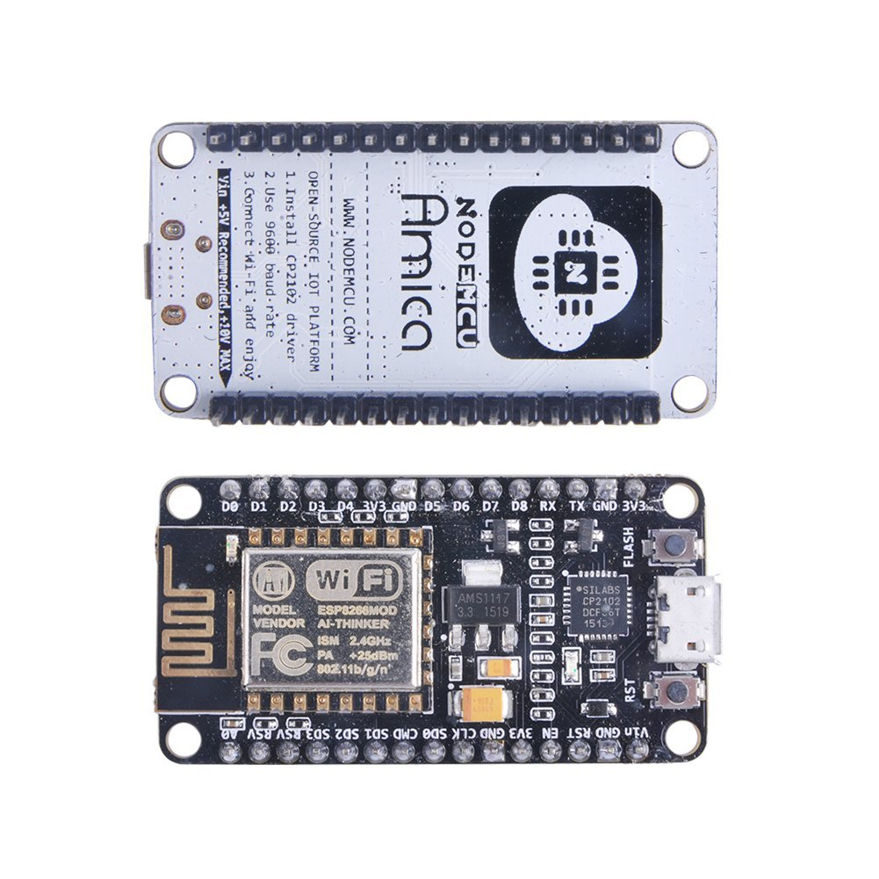

Fig 4.1: Node-MCU

Node-MCU is an open source IoT platform. It includes firmware which runs on the ESP8266 Wi-Fi SoC from Espressif Systems, and hardware which is based on the ESP-12 module. The term "Node-MCU" by default refers to the firmware rather than the development kits. The firmware uses the Lua scripting language. It is based on the eLua project, and built on the Espressif Non-OS SDK for ESP8266. It uses many open source projects, such as lua-cjson, and spiffs.

Node-MCU was created shortly after the ESP8266 came out. On December 30, 2013, Espressif Systems began production of the ESP8266. The ESP8266 is a Wi-Fi SoC integrated with a Tensilica Xtensa LX106 core,[citation needed] widely used in IoT applications (see related projects). Node-MCU started on 13 Oct 2014, when Hong committed the first file of Node-MCU-firmware to GitHub. Two months later, the project expanded to include an open-hardware platform when developer Huang R committed the gerber file of an ESP8266 board, named devkit v0.9. Later that month, Tuan PM ported MQTT client library from Contiki to the ESP8266 SoC platform, and committed to Node-MCU project, then Node-MCU was able to support the MQTT IoT protocol, using Lua to access the MQTT broker. Another important update was made on 30 Jan 2015, when Devsaurus ported the u8glib to Node-MCU project, enabling Node-MCU to easily drive LCD, Screen, OLED, even VGA displays.

In summer 2015 the creators abandoned the firmware project and a group of independent but dedicated contributors took over. By summer 2016 the Node-MCU included more than 40 different modules. Due to resource constraints users need to select the modules relevant for their project and build a firmware tailored to their needs.

As Node-MCU.cc began developing new MCU boards based on non-AVR processors like the ARM/SAM MCU and used in the Node-MCU Due, they needed to modify the Node-MCU IDE so that it would be relatively easy to change the IDE to support alternate tool chains to allow Node-MCU C/C++ to be compiled down to these new processors. They did this with the introduction of the Board Manager and the SAM Core. A "core" is the collection of software components required by the Board Manager and the Node-MCU IDE to compile an Node-MCU C/C++ source file down to the target MCU's machine language. Some creative ESP8266 enthusiasts have developed an Node-MCU core for the ESP8266 Wi-Fi SoC that is available at the GitHub ESP8266 Core webpage. This is what is popularly called the "ESP8266 Core for the Node-MCU IDE" and it has become one of the leading software development platforms for the various ESP8266 based modules and development boards, including Node-MCU.

Programming Model:

The Node-MCU programming model is similar to that of Node.js, only in Lua. It is asynchronous and event-driven. Many functions, therefore, have parameters for callback functions. To give you an idea what a Node-MCU program looks like study the short snippets below. For more extensive examples have a look at the /lua examples folder in the repository on GitHub.

|  |  |
| --- | --- |
| Developer | ESP8266 Open source Community |
| Type | Single-board microcontroller |
| Operating system | XTOS |
| CPU | ESP8266(LX106) |
| Memory | 128kBytes |
| Storage | 4Mbytes |
| Power | USB |
| Website | [www.Node-MCU.com](http://www.nodemcu.com),  reference: Node-MCU.readthedocs.io |

Table: Node-MCU devkit

**Node-MCU pin diagram**:

While writing GPIO code on Node-MCU, you can’t address them with actual GPIO Pin Numbers. There are different I/O Index numbers assigned to each GPIO Pin which is used for GPIO Pin addressing. Refer following table to check I/O Index of Node-MCU GPIO Pins

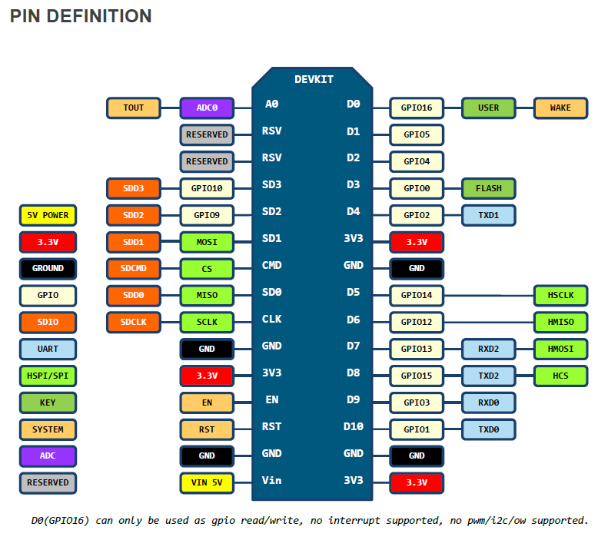

Fig 4.2: Node-MCU pin diagram

**4.2 BREADBOARD:**

A breadboard is a construction base for prototyping of electronics. Originally it was literally a bread board, a polished piece of wood used for slicing bread. In the 1970s the solderless breadboard (a.k.a. plug board, a terminal array board) became available and nowadays the term "breadboard" is commonly used to refer to these. Because the solderless breadboard does not require soldering, it is reusable.

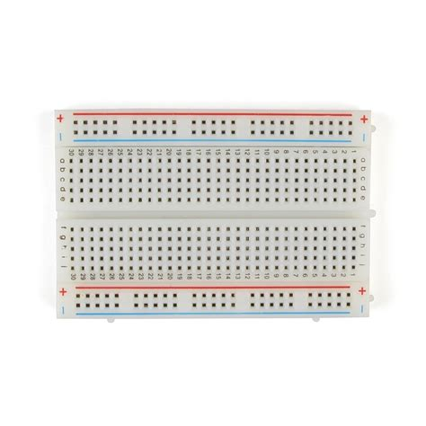

Fig 4.3 : Bread board

This makes it easy to use for creating temporary prototypes and experimenting with circuit design. For this reason, solderless breadboards are also popular with students and in technological education. Older breadboard types did not have this property. A stripboard (Veroboard) and similar prototyping printed circuit boards, which are used to build semi-permanent soldered prototypes or one-offs, cannot easily be reused. A variety of electronic systems may be prototyped by using breadboards, from small analog and digital circuits to complete central processing units (CPUs).

Breadboards have evolved over time, with the term now being used for all kinds of prototype electronic devices. For example, US Patent 3,145,483, was filed in 1961 and describes a wooden plate breadboard with mounted springs and other facilities.

The breadboard most commonly used today is usually made of white plastic and is a pluggable (solderless) breadboard. It was designed by Ronald J. Portugal in 1971.

To provide power to the electronic components. A bus strip usually contains two rows: one for ground and one for a supply voltage. However, some breadboards only provide a single-row power distributions bus strip on each long side. Typically the row intended for a supply voltage is marked in red, while the row for ground is marked in blue or black. Some manufacturers connect all terminals in a column. Others just connect groups of, for example, 25 consecutive terminals in a column. The latter design provides a circuit designer with some more control over crosstalk (inductively coupled noise) on the power supply bus. Often the groups in a bus strip are indicated by gaps in the color marking.

Bus strips typically run down one or both sides of a terminal strip or between terminal strips. On large breadboards additional bus strips can often be found on the top and bottom of terminal strips.

Note there are two different common alignments for the power bus strips. On small boards, with about 30 rows, the holes for the power bus are often aligned between the signal holes. On larger boards, about 63 rows, the power bus strip holes are often in alignment with the signal holes. This makes some accessories designed for one board type incompatible with the other. For example, some Raspberry Pi GPIO to breadboard adapters use offset aligned power pins, making them not fit breadboards with aligned power bus rows. There are no official standards, so the users need to pay extra attention to the compatibility between a specific model of breadboard and a specific accessory. Vendors of accessories and breadboards are not always clear in their specifications of which alignment they use. Seeing a close up photograph of the pin/hole arrangement can help determine compatibility.

Some manufacturers provide separate bus and terminal strips. Others just provide breadboard blocks which contain both in one block. Often breadboard strips or blocks of one brand can be clipped together to make a larger breadboard.

In a more robust variant, one or more breadboard strips are mounted on a sheet of metal. Typically, that backing sheet also holds a number of binding posts. These posts provide a clean way to connect an external power supply. This type of breadboard may be slightly easier to handle. Several images in this article show such solderless breadboards.

**4.3 HC-SR04 Ultrasonic:**

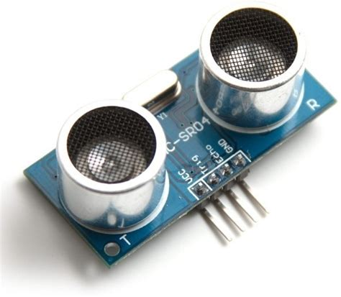

**Fig 4.4 : Ultrasonic sensor**

**Ultrasonic sensors** (also known as **transceivers** when they both send and receive) work on a principal similar to radar or sonar which evaluate attributes of a target by interpreting the echoes from radio or sound waves respectively. Ultrasonic sensors generate high frequency sound waves and evaluate the echo which is received back by the sensor. Sensors calculate the time interval between sending the signal and receiving the echo to determine the distance to an object.

This technology can be used for measuring: wind speed and direction (anemometer), fullness of a tank and speed through air or water. For measuring speed or direction a device uses multiple detectors and calculates the speed from the relative distances to particulates in the air or water. To measure the amount of liquid in a tank, the sensor measures the distance to the surface of the fluid. Further applications include: [humidifiers](http://www.thefullwiki.org/Humidifier), [sonar](http://www.thefullwiki.org/Sonar), [medical ultrasonography](http://www.thefullwiki.org/Medical_ultrasonography), burglar alarms and [non-destructive testing](http://www.thefullwiki.org/Non-destructive_testing).

Systems typically use a transducer which generates sound waves in the ultrasonic range, above 20,000 hertz, by turning electrical energy into sound, then upon receiving the echo turn the sound waves into electrical energy which can be measured and displayed. The technology is limited by the shapes of surfaces and the density or consistency of the material. For example foam on the surface of a fluid in a tank could distort a reading.

[Ultrasonic](https://en.wikipedia.org/wiki/Ultrasound) level sensors are used for non-contact level sensing of highly viscous liquids, as well as bulk solids. They are also widely used in water treatment applications for pump control and open channel flow measurement. The sensors emit high frequency (20 kHz to 200 kHz) acoustic waves that are reflected back to and detected by the emitting transducer.

Ultrasonic level sensors are also affected by the changing [speed of sound](https://en.wikipedia.org/wiki/Speed_of_sound) due to moisture, temperature, and pressures. Correction factors can be applied to the level measurement to improve the accuracy of measurement.

Turbulence, foam, steam, chemical mists (vapors), and changes in the concentration of the process material also affect the ultrasonic sensor’s response. Turbulence and foam prevent the sound wave from being properly reflected to the sensor; steam and chemical mists and vapors distort or absorb the sound wave; and variations in concentration cause changes in the amount of energy in the sound wave that is reflected back to the sensor. Stilling wells and waveguides are used to prevent errors caused by these factors. Proper mounting of the transducer is required to ensure the best response to reflected sound.

In addition, the hopper, bin, or tank should be relatively free of obstacles such as weldments, brackets, or ladders to minimize false returns and the resulting erroneous response, although most modern systems have sufficiently "intelligent" echo processing to make engineering changes largely unnecessary except where an intrusion blocks the "line of sight" of the transducer to the target.

Since the ultrasonic transducer is used both for transmitting and receiving the acoustic energy, it is subject to a period of mechanical vibration known as “ringing”. This vibration must attenuate (stop) before the echoed signal can be processed. The net result is a distance from the face of the transducer that is blind and cannot detect an object. It is known as the “blanking zone”, typically 150mm – 1m, depending on the range of the transducer.

The requirement for electronic signal processing circuitry can be used to make the ultrasonic sensor an intelligent device. Ultrasonic sensors can be designed to provide point level control, continuous monitoring or both. Due to the presence of a microprocessor and relatively low power consumption, there is also the capability for serial communication from to other computing devices making this a good technique for adjusting calibration and filtering of the sensor signal, remote wireless monitoring or plant network communications. The ultrasonic sensor enjoys wide popularity due to the powerful mix of low price and high functionality.

**4.4 Voltage regulators:**

A voltage regulator is a system designed to automatically maintain a [constant voltage](https://en.wikipedia.org/wiki/Voltage_source) level. A voltage regulator may use a simple [feed-forward](https://en.wikipedia.org/wiki/Feed_forward_(control)) design or may include [negative feedback](https://en.wikipedia.org/wiki/Negative_feedback). It may use an [electromechanical mechanism](https://en.wikipedia.org/wiki/Electromechanics), or [electronic components](https://en.wikipedia.org/wiki/Electronic_component). Depending on the design, it may be used to regulate one or more [AC](https://en.wikipedia.org/wiki/Alternating_current) or [DC](https://en.wikipedia.org/wiki/Direct_current) voltages.

Electronic voltage regulators are found in devices such as computer [power supplies](https://en.wikipedia.org/wiki/Power_supply) where they stabilize the DC voltages used by the processor and other elements.

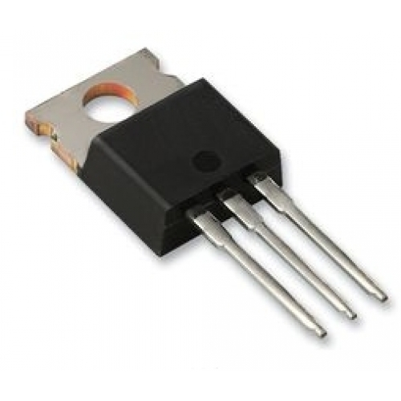

Fig 4.5: IC 7805 voltage regulator

In automobile [alternators](https://en.wikipedia.org/wiki/Alternator) and central [power station](https://en.wikipedia.org/wiki/Power_station) generator plants, voltage regulators control the output of the plant. In an [electric power distribution](https://en.wikipedia.org/wiki/Electric_power_distribution) system, voltage regulators may be installed at a [substation](https://en.wikipedia.org/wiki/Electrical_substation) or along [distribution lines](https://en.wikipedia.org/wiki/Electric_power_distribution) so that all customers receive steady voltage independent of how much power is drawn from the line.

Voltage regulators or stabilizers are used to compensate for voltage fluctuations in mains power. Large regulators may be permanently installed on distribution lines. Small portable regulators may be plugged in between sensitive equipment and a wall outlet. Automatic voltage regulators are used on generator sets on ships, in emergency power supplies, on oil rigs, etc. to stabilize fluctuations in power demand. For example, when a large machine is turned on, the demand for power is suddenly a lot higher. The voltage regulator compensates for the change in load. Commercial voltage regulators normally operate on a range of voltages, for example 150–240 V or 90–280 V. Servo stabilizers are also manufactured and used widely in spite of the fact that they are obsolete and use out-dated technology.

Voltage regulators are used in devices like air conditioners, refrigerators, televisions etc. in order to protect them from fluctuating input voltage.

Connections of 5v voltage regulator:

* It consists of 3 pins.
* First pin is to be given to positive of power supply(from left to right).
* Second pin is given to negative of power supply.
* Second pin is also given to output negative.
* Third pin is given to output positive.

Pin diagram of 5v voltage regulator:

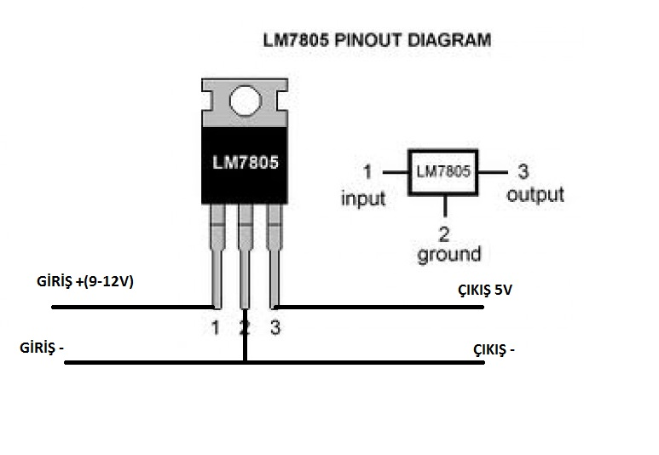

Fig 4.6: IC7805 pin diagram

**4.5 JUMPER WIRES:**

A jump wire is an electrical wire, or group of them in a cable, with a connector or pin at each end, which is normally used to interconnect the components of a breadboard or other prototype or test circuit, internally or with other equipment or components, without soldering.

**Jumper wire types:**

* Male to Male.
* Male to Female.
* Female to Female.
* The term "jumper wire" simply refers to a conducting wire that establishes an electrical connection between points in a circuit. You can use jumper wires to modify a circuit or to diagnose problems in a circuit. The following steps outline how you can safely use jumper wires in different electrical applications. Female to Female.

Fig 4.7: Female to Male jumpers Fig 4.8: Female to Feamle jumpers

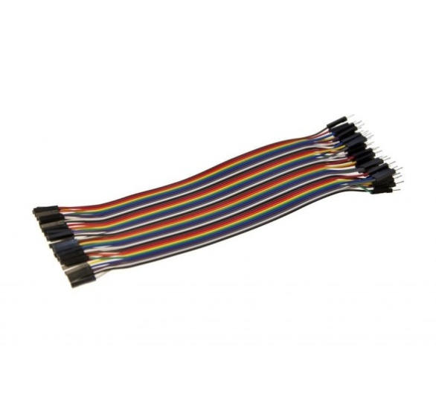 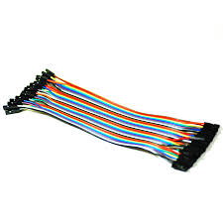

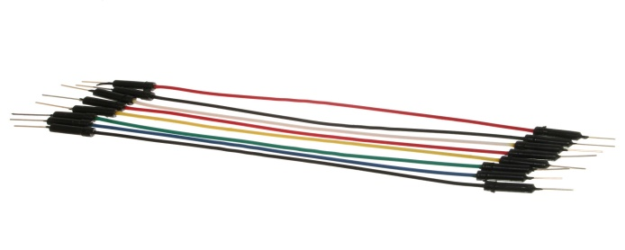

Fig 4.9:Male to Male jumpers

**4.6 SLIDE SWITCH:**

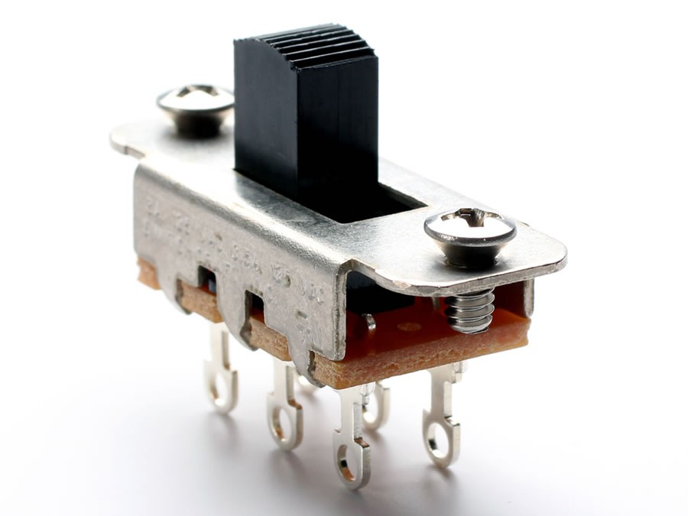

Fig 4.10: Slide switch

In [electrical engineering](https://en.wikipedia.org/wiki/Electrical_engineering), a switch is an [electrical component](https://en.wikipedia.org/wiki/Electrical_component) that can "make" or "break" an [electrical circuit](https://en.wikipedia.org/wiki/Electrical_circuit) interrupting the [current](https://en.wikipedia.org/wiki/Electric_current) or diverting it from one conductor to another. The mechanism of a switch removes or restores the conducting path in a circuit when it is operated. It may be operated manually, for example, a light switch or a keyboard button, may be operated by a moving object such as a door, or may be operated by some sensing element for pressure, temperature or flow. A switch will have one or more sets of contacts, which may operate simultaneously, sequentially, or alternately. Switches in high-powered circuits must operate rapidly to prevent destructive arcing, and may include special features to assist in rapidly interrupting a heavy current. Multiple forms of actuators are used for operation by hand or to sense position, level, temperature or flow. Special types are used, for example, for control of machinery, to reverse electric motors, or to sense liquid level. Many specialized forms exist. A common use is control of lighting, where multiple switches may be wired into one circuit to allow convenient control of light fixtures.

By analogy with the devices that select one or more possible paths for electric currents, devices that route information in a computer network are also called "switches" - these are usually more complicated than simple electromechanical toggles or pushbutton devices, and operate without direct human interaction.

**4.7 9V BATTERY:**

The nine-volt battery format is commonly available in primary carbon-zinc and alkaline chemistry, in primary lithium iron disulfide, and in rechargeable form in nickel-cadmium, nickel-metal hydride and lithium-ion. Mercury-oxide batteries of this format, once common, have not been manufactured in many years due to their mercury content .

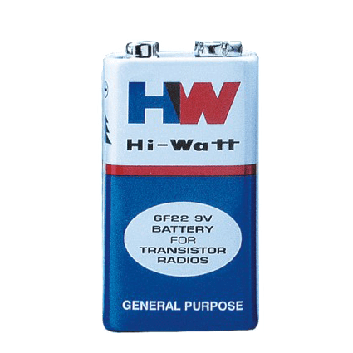

Fig 4.11: Battery

**Connectors:**

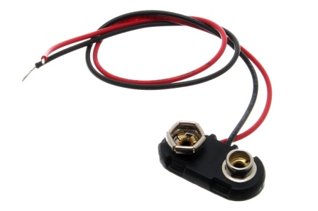

Fig 4.12: Connectors

The battery has both [terminals](https://en.wikipedia.org/wiki/Battery_terminals) in a snap connector on one end. The smaller circular (male) terminal is positive, and the larger hexagonal or octagonal (female) terminal is the negative contact. The connectors on the battery are the same as on the connector itself; the smaller one connects to the larger one and vice versa.

**4.8 LED:**

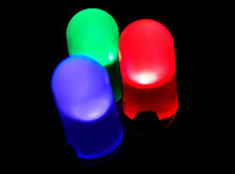

Fig 4.13: LED

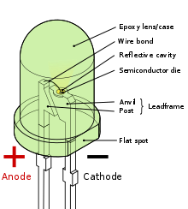

Fig 4.14: LED pin diagram

A light-emitting diode (LED) is a two-lead semiconductor light source. It is a p–n junction diode that emits light when activated. When a suitable current is applied to the leads, electrons are able to recombine with electron holes within the device, releasing energy in the form of photons. This effect is called electroluminescence, and the color of the light (corresponding to the energy of the photon) is determined by the energy band gap of the semiconductor. LEDs are typically small (less than 1 mm2) and integrated optical components may be used to shape the radiation pattern.

Appearing as practical electronic components in 1962, the earliest LEDs emitted low-intensity infrared light. Infrared LEDs are still frequently used as transmitting elements in remote-control circuits, such as those in remote controls for a wide variety of consumer electronics. The first visible-light LEDs were of low intensity and limited to red. Modern LEDs are available across the visible, ultraviolet, and infrared wavelengths, with very high brightness.

Early LEDs were often used as indicator lamps for electronic devices, replacing small incandescent bulbs. They were soon packaged into numeric readouts in the form of seven-segment displays and were commonly seen in digital clocks. Recent developments have produced LEDs suitable for environmental and task lighting. LEDs have led to new displays and sensors, while their high switching rates are useful in advanced communications technology.

LEDs have many advantages over incandescent light sources, including lower energy consumption, longer lifetime, improved physical robustness, smaller size, and faster switching. Light-emitting diodes are used in applications as diverse as aviation lighting, automotive headlamps, advertising, general lighting, traffic signals, camera flashes, lighted wallpaper and medical devices. They are also significantly more energy efficient and, arguably, have fewer environmental concerns linked to their disposal

Unlike a laser, the color of light emitted from an LED is neither coherent nor monochromatic, but the spectrum is narrow with respect to human vision, and for most purposes the light from a simple diode element can be regarded as functionally monochromatic.

**CHAPTER 5**

**CONSTRUCTION AND DESIGN**

**5.1 DESIGN OF THE IOT BASED GARBAGE MONITORING SYSTEM:**

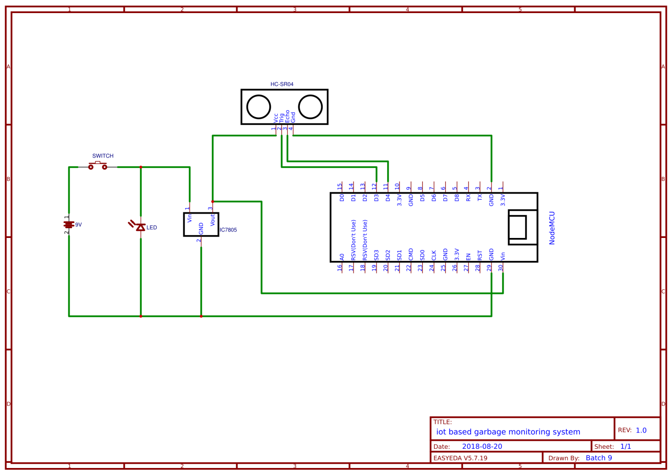

Fig 5.1: schematic sketch of garbage monitoring system using IoT

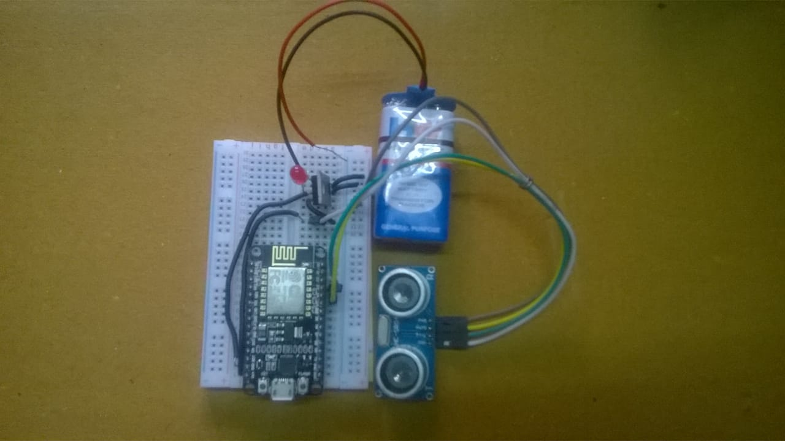

Fig 5.2: hardware of garbage monitoring system using IoT for a single dustbin

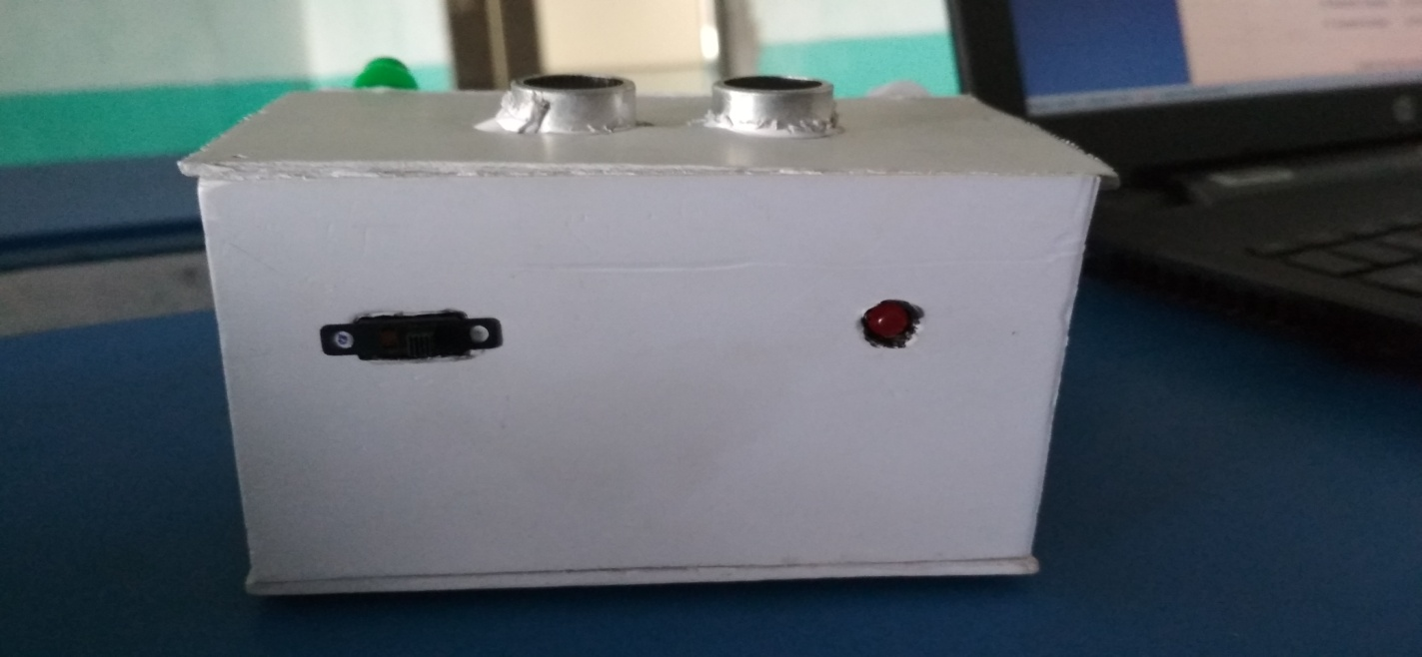

Fig 5.3: complete model of garbage monitoring system using IoT

**5.2 STEPS IN THE CONSTRUCTION OF THE SMART GARBAGE BIN:**

* The Ultrasonic-sensor is connected to the Node-MCU with the help of the jumper wires.
* The trigger pin and echo pin of the ultrasonic-sensor is connected to pins D3 and D4 of Node-MCU which output and input pins.
* A 9v battery is use as a power source. This battery supplies power to the whole circuit via a switch and a IC7805 voltage regulator.
* The positive terminal for the battery is connect to the switch and the negative terminal acts as a common ground.
* From the other end of the switch a wire is connected to the IC7805 voltage regulator’s input terminal. And the ground pin of the regulator is connect to the common ground where the negative terminal of the battery is connected.
* Form the output pin of the regulator a regulated voltage of 5v is drawn with the help of a jumper. Now this used for powering both the Node-MCU and ultrasonic-sensor.
* The wire which is drawn from the output pin is connect to the Vin of the Node-MCU and the ground of the Node-MCU is connect to the common ground.
* The Vcc pin of the ultrasonic sensor is connect to the output pin of the regulator. And the ground is connect to the common ground.
* After the formation of the circuit an algorithm is designed for the interfacing of Node-MCU and Ultrasonic sensor.
* From the algorithm an embedded c program is written in Node-MCU IDE and then the code is uploaded to the Node-MCU.
  1. **WORKING OF THE PROJECT:**

Each bin is connected with a complete circuit of Node-MCU, Ultrasonic-sensor, IC7805 voltage regulator, 9v battery, switch and a led.

* When the circuit is powered the Node-MCU starts receiving data from the ultrasonic sensor.
* Ultrasonic sensors use sound to determine the distance between the sensor and the closest object in its path.
* The sensor sends out a sound wave at a specific frequency. It then listens for that specific sound wave to bounce off of an object and come back.
* The sensor keeps track of the time between sending the sound wave and the sound wave returning. If you know how fast something is going and how long it is traveling you can find the distance traveled with the help of the formula d=v × t.
* The HC­SR04 can be triggered to send out an ultrasonic burst by setting the TRIG pin to HIGH. Once the burst is sent the ECHO pin will automatically go HIGH. This pin will remain HIGH until the burst hits the sensor again.
* This whole procedure is controlled by the Node-MCU which is set by a predefined values.
* When the ultrasonic sensor is calculated the distance (the level of the bin) this data is send to the Node-MCU.
* The Node-MCU then sends this data to the database(in this case its firebase).
* This data is then updated into their particular fields.
* Then this data is send to the hosting server which shows the status of bins in a webpage.
* This webpage is automatically updated for every 20 seconds showing the status of the bins.

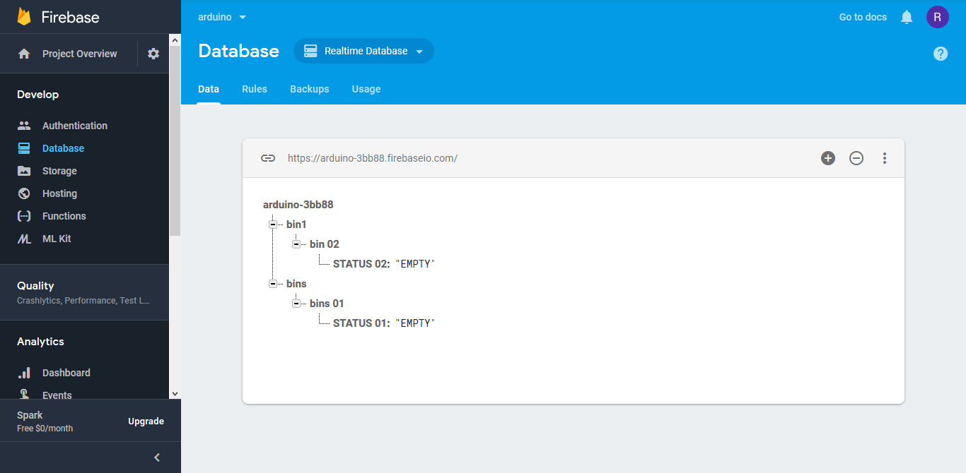

Fig 5.4 : connecting with Firebase

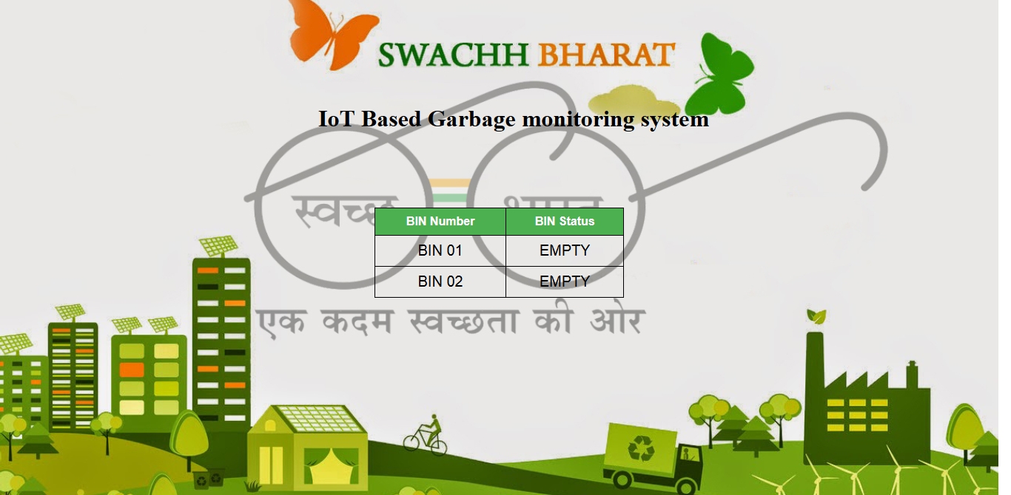

Fig 5.5: output on a webpage when bins are empty

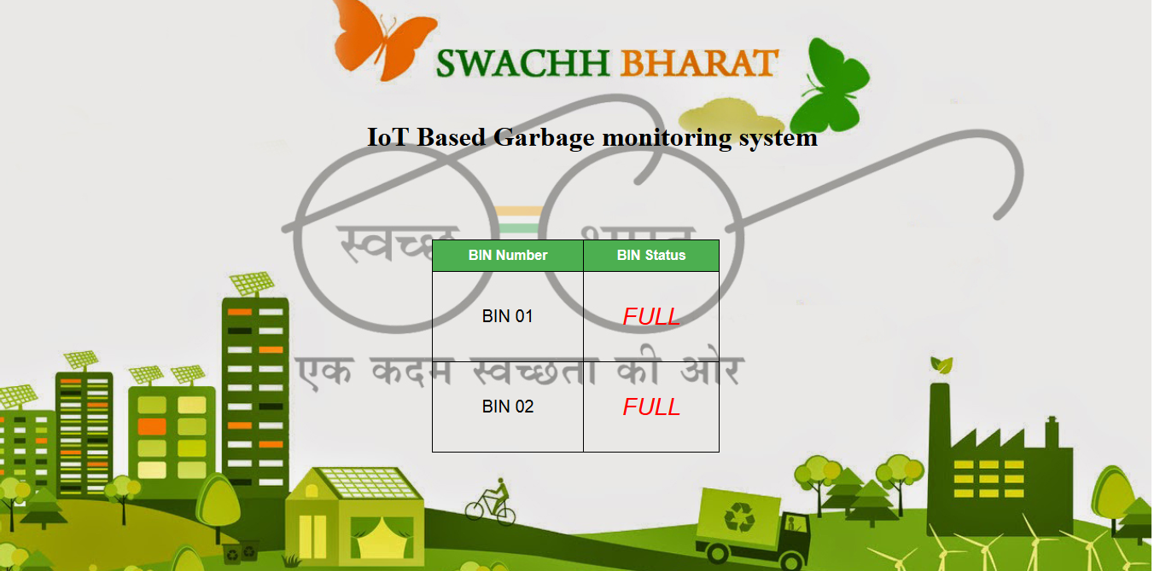

Fig 5.6: output on a webpage when bins are full

**CHAPTER 6**

**RESULTS**

The following are the results which are obtained from this work.

• Waste level detection inside the dustbin.

• Transmit the information wirelessly to concern.

• The data can be accessed any time and from anywhere.

• The real time data transmission and access.

• Avoids the overflow of the dustbin.

This waste management system using IoT is very useful for smart cities in diverse aspects. In the cities there are dissimilar dustbins located in different areas and dustbins become over flown many times and the concerned people do not get info about this. This system is designed to crack this issue and will offer complete details of the dustbins located in different areas throughout the city. The allocated authority can access the information from anywhere and anytime to get the details. Accordingly they can renew the decision on this immediately.

**CHAPTER 7**

**CONCLUSION AND FUTURE SCOPE**

The ultimate objective of this study was to use the results and conclusions obtained from understanding the existing procedures in waste management in a reflective manner, in order to improve the current scenario of waste management not only in the urban areas but to be able to spread it to the rural areas. This has to be built more along the lines of making it a habit that is required. It is said that the necessity is the mother of invention. Hence in the deep crisis of waste management that the country faces today, this is a viable and a much needed requirement to be able to cope with the rising waste in this nation. There are many campaigns that have taken shape such as the Swachh Bharat campaign.

This system caters to automate the most basic and very important service in building waste management system using IoT which monitors garbage levels continuously. Therefore this system needs to be very efficient and perform seamlessly without much delay also smoothly without many deviations. For this it is important to keep the logical part of the system as simple as possible and also consider all cases while designing and testing.

The IoT Garbage monitoring system pays a lot towards clean and disinfected pollution less environment in building a smart city. As these technology is new in India there should be appropriate consciousness and alertness among the public before the operation of this technology.

Otherwise, sensitive devices like sensors might be spoiled due to rough action of the users. It is an automatic dust bin monitoring system in order to sense the full condition of the garbage bins. This provides the authorized users appropriate updates of the location of the garbage bins and thus eliminates the need of intermittent manual checks and overflowing garbage bins. This method finally helps in keeping the environment clean. Thus, the garbage collection is made more efficient, effective and operative.

**REFERENCES**

[1] M. T. Lazarescu, “Design of a WSN platform for long-term environmental monitoring for IoT applications,” IEEE Journal on Emerging and Selected Topics in Circuits and Systems,vol.3,no. 1, pp. 45–54, 2013

[2] S.D.T.Kelly, N.K.Suryadevara, and S.C.Mukhopadhyay, “Towards the implementation of IoT for environmental condition monitoring in homes” IEEE Sensors Journal, vol.13, no.10, pp. 3846–3853, 2013.

[3] Upadhyay, V. P., M. R. Prasad, A. Srivastav & K. Singh. 2005. Eco tools for urban waste management in India. Journal of Human Ecology 18: 253-269.

[4] Sharholy, M., Ahmad, K., Mahmood, G., Trivedi, R.C., 2008. Municipal Solid waste management in Indian cities. A review, Journal of Waste Management 28,459-467.

[5] Agarwal, A., Singhmar, A., Kulshrestha, M., Mittal, A.K., 2005. Municipal solid waste recycling and associated markets in Delhi, India. Journal of Resources, Conservation and Recycling 44(1), 73-90. Ashan, N., 1999.

[6] S.Tozlu, M.Senel, W. Mao, and A. Keshavarzian, “Wi-Fienabled sensors for internet of things: a practical approach,” IEEE Communications Magazine,vol.50,no.6,pp.134–143,2012.

**APPENDIX**

**HTML CODE FOR THE WEBPAGE:**

<!DOCTYPE html>

<html lang="en" dir="ltr">

<head>

<meta charset="utf-8">

<meta http-equiv="refresh" content="10" >

<title>iot</title>

<style>

html, body

{

height: 100%;

margin: 0px;

}

.bg

{

background-image: url("images/image.jpg");

height: 104%;

background-position: center;

background-repeat: no-repeat;

background-size: cover;

}

h1

{

text-align: left;

padding-bottom: 80px;

padding-left: 430px;

padding-top: 120px;

}

table

{

font-family: arial, sans-serif;

border-collapse: collapse;

width: 25%;

margin-left: auto;

margin-right: auto;

}

td

{

border: 1.5px solid #000000;

text-align: center;

padding: 8px;

font-size: 20px;

}

th

{

border: 1.5px solid #000000;

text-align: center;

padding: 8px;

background-color: #4CAF50;

color: white;

}

P

{

font-style: italic;

font-size: 28px;

}

</style>

</head>

<body class="bg">

<h1> IoT Based Garbage monitoring system </h1>

<table >

<thead>

<th>BIN Number</th>

<th>BIN Status</th>

</thead>

<tbody id="t1">

</tbody>

</table>

</body>

<script src="https://www.gstatic.com/firebasejs/5.3.1/firebase.js"></script>

<script>

// Initialize Firebase

var config = {

apiKey: "Api_key",

authDomain: "Your_project.firebaseapp.com",

databaseURL: "http:// your_project.firebase.com",

projectId: "your_project_name",

storageBucket: "your_project_name.appspot.com",

messagingSenderId: "915714772100"

};

firebase.initializeApp(config);

</script>

<script type="text/javascript" src="https://code.jquery.com/jquery-3.3.1.js">

</script>

<script type="text/javascript" src="index.js"></script>

</html>

**JAVASCRIPT CODE FOR THE INITIALIZATION OF FIREBASE:**

var rootRef = firebase.database().ref().child("bins");

rootRef.on("child_added", snap => {

var status = snap.child("STATUS 01").val();

$("#t1").append("<tr><td>BIN 01</td><td>"+ status +"</td></tr>");

});

var rootRef = firebase.database().ref().child("bin1");

rootRef.on('child_added', snap => {

var status1 = snap.child("STATUS 02").val();

$("#t1").append("<tr><td>BIN 02</td><td>"+ status1 +"</td></tr>");

});

**CODE FOR FIRST NODE-MCU:**

//CODE FOR BIN 01

#include <FirebaseNode-MCU.h>

#include <ESP8266WiFi.h>

//needed for library

#include <DNSServer.h>

#include <ESP8266WebServer.h>

#include <WiFiManager.h> //https://github.com/tzapu/WiFiManager

#define FIREBASE_HOST "your_project.firebaseio.com"

#define FIREBASE_AUTH "AUTH_TOKEN"

const int trigPin = 0; // D3

const int echoPin = 2; // D4

// defining two variable for measuring the distance

long duration;

int distance;

void setup() {

Serial.begin(115200);

WiFiManager wifiManager;

wifiManager.autoConnect("IOT");

Serial.println("connected...");

pinMode(trigPin, OUTPUT); // Setting the trigPin as Output pin

pinMode(echoPin, INPUT); // Setting the echoPin as Input pin

Firebase.begin(FIREBASE_HOST, FIREBASE_AUTH);

}

void loop(){

digitalWrite(trigPin, LOW); // Making the trigPin as low

delayMicroseconds(2); // delay of 2us

digitalWrite(trigPin, HIGH); // making the trigPin high for 10us to send the signal

delayMicroseconds(10);

digitalWrite(trigPin, LOW);

duration = pulseIn(echoPin, HIGH); // reading the echoPin which will tell us that how much time the signal takes to come back

//

distance= duration*0.034/2; // Calculating the distance and storing in the distance variable

if(distance < 10){

Firebase.setString("bins/bins 01/STATUS 01", "<p style=\"color : red\" >FULL</p>");

}

else{

Firebase.setString("bins/bins 01/STATUS 01", "EMPTY");

}

}

**CODE FOR SECOND NODE-MCU:**

//CODE FOR BIN 02

#include <FirebaseNode-MCU.h>

#include <ESP8266WiFi.h>

//needed for library

#include <DNSServer.h>

#include <ESP8266WebServer.h>

#include <WiFiManager.h> //https://github.com/tzapu/WiFiManager

#define FIREBASE_HOST "your_project.firebaseio.com"

#define FIREBASE_AUTH "AUTH_TOKEN"

const int trigPin = 0; // D3

const int echoPin = 2; // D4

// defining two variable for measuring the distance

long duration;

int distance;

void setup() {

Serial.begin(115200);

WiFiManager wifiManager;

wifiManager.autoConnect("IOT");

Serial.println("connected...");

pinMode(trigPin, OUTPUT); // Setting the trigPin as Output pin

pinMode(echoPin, INPUT); // Setting the echoPin as Input pin

Firebase.begin(FIREBASE_HOST, FIREBASE_AUTH);

}

void loop(){

digitalWrite(trigPin, LOW); // Making the trigPin as low

delayMicroseconds(2); // delay of 2us

digitalWrite(trigPin, HIGH); // making the trigPin high for 10us to send the signal

delayMicroseconds(10);

digitalWrite(trigPin, LOW);

duration = pulseIn(echoPin, HIGH); // reading the echoPin which will tell us that how much time the signal takes to come back

//

distance= duration*0.034/2; // Calculating the distance and storing in the distance variable

// // put your main code here, to run repeatedly:

if(distance < 10){

Firebase.setString("bin1/bin 02/STATUS 02", "<p style=\"color:red\" >FULL</p>");

}

else{

Firebase.setString("bin1/bin 02/STATUS 02", "EMPTY");

}

}

**BIODATA:**

